***Saint Charles Borromeo***

***Catholic Church***

***Catholic Diocese of Richmond***

***Rev. J. Michael Breslin*, *Pastor***

***Deacon Donald T. Donovan***



**545 Randolph Avenue, Cape Charles, VA 23310**

**Office 757-331-2040 Rectory 757 -331-1724**

**E-mail:** [**saintcharles545@gmail.com**](mailto:saintcharles545@gmail.com)

**Website:** [**www.stcharlesbcc.org**](http://www.stcharlesbcc.org)

**OUR MISSION STATEMENT**

Saint Charles Borromeo Parish is a Catholic Community of Faith which is dedicated to prayerful worship of our Lord and Savior, providing a welcoming place to others, Christian service to all our neighbors and grateful stewardship of our earthly home.

**Mass Schedule (subject to change)**

**Saturday Evening Vigil Mass**

5:00 PM

**Sunday Mass**

**10:00 AM September to May**

9:00 AM Memorial Day Weekend to Labor Day Weekend

**4:00 PM Spanish**

**Daily**

9:30 AM (Wednesday – Friday)

**Holy Days**

Call for Schedule

**Welcome to Our Parish**

*We are happy to welcome you with great joy to our Faith Community! New Parishioners are requested to register. Please fill out a Parish registration form so we have a record of you and your family. We also welcome you to become an active member of the Parish. Please obtain a registration form from the rear of the Church or the Parish Office. Also, if you are moving, please notify the Parish Office.*

**September 25, 2022**

**26th Sunday in Ordinary Time**

**Saint Charles Parish Staff**

Irene Henderson, *Office Manager*

Michael Flanagan, *Music Director*

Jeanne Roll, *Organist Sunday*

Alicia Brady, *Organist Saturday*

Marge Surran, *Archivist*

Gail McCormick, *Bulletin Editor*

E-mail: [**bulletinscc@gmail.com**](mailto:bulletinscc@gmail.com)

**Saint Charles Parish Ministries**

David Scott*, Parish Council Chairperson*

Kevin Fallon, *Parish Council Vice Chairperson*

Karen Leffel*, Parish Council Secretary*

Bob Panek*, Finance Council Chairperson*

Mike Strub*, Social Ministry*

Mary Beth Briggs, *Ecumenical Ministry*

Tara Ashworth, *Fundraising Ministry*

Karey Fallon, *Migrant Ministry*

Joan Natali*, Helping Hands Social Ministry*

Jeanette Orzo and David Scott, *Parish Life Ministry*

Pat Hill and Scottie Paschall, *Worship Ministry*

Guadalupe Panuco, *Hispanic Ministry*

Karey and Kevin Fallon*, Religious Education Ministry*

**Adoration** – First Friday after the 9:30 a.m. Mass

**Marriage** – By Appointment

At least 6 months prior to the marriage

**Baptism** – By Appointment

**Order of C.I.A.** – Deacon Don Donovan,

Home: (757) 678-9019, Cell: (757) 999-1172

**Reconciliation** – By Request

**Religious Education** – October through May

**Parish Council** – 3rd Tuesday at 6:30 p.m.

**Parish Office Hours** – Tuesday–Thursday 9:30 a.m.-3:00 p.m.

**Saint Charles Church is open for prayer Wednesday through Sunday during the hours of 9:00 a.m. and 5:00 p.m.**



**SEPTEMBER 24TH SATURDAY 5:00 P.M.:**

* **The Living and Deceased of Our Parish Family**

**SEPTEMBER 25TH SUNDAY 10:00 A.M.:**

* **Michael Mlodynia and**
* **Ted Karmilovich**

**SEPTEMBER 28TH WEDNESDAY 9:30 A.M.:**

* **Karl & Mary Ann Efferts**

**SEPTEMBER 29TH THURSDAY 9:30 A.M.:**

* **Denyse Malouf**

**SEPTEMBER 30TH FRIDAY 9:30 A.M.:**

* **Fred Swanson**

**OCTOBER 1ST SATURDAY 5:00 P.M.:**

* **The Living and Deceased of Our Parish Family**

**OCTOBER 2ND SUNDAY 10:00 A.M.:**

* **Janie Loysch & her son, Eddy**

**OCTOBER 2ND SUNDAY 4:00 P.M.:**

* **SPANISH MASS**

**Nuestra misa en español se celebra todos los domingos a las 4 p.m. ¡Todos son bienvenidos!**

**Our Spanish Mass is celebrated every Sunday at 4:00 p.m. Everyone is welcome**!

**\* * \***

**MINISTRY SCHEDULE FOR NEXT WEEKEND**

**Saturday, October 1st 5:00 PM Mass:**

**Greeters:** JoAnn Clark, Andrea Scott

**Ushers:** Bob Leffel, Dick Surran

**Lector:** Kevin Fallon

**Altar Servers:** Jeffrey Rathz, Robert Toner

**Eucharistic Minister:** Mark Clarke

**Sunday, October 2nd 10:00 AM Mass:**

**Greeters:** Maureen Bochman, Pat James

**Ushers:** Robert James, Bill Nottingham

**Lector:** Peggy Phillips

**Altar Servers:** OPEN/NEEDED

**Eucharistic Minister:** Evelyn Pinili

**Domingo, 2 de octubre a las 4:00 de la tarde:**

**Lectores:** Edith Palacios, Cristal P.

**Monaguillos:** Fernando, Lizania, Yoseline

**Ministro de eucarístia:** Zeferino

**Healing Prayer**

**LORD**, You invite all who are burdened to come to You. Allow Your healing hand to heal me. Touch my soul with Your compassion for others. Touch my heart with Your courage and infinite love for all. Touch my mind with Your wisdom, that my mouth may always proclaim Your praise. Teach me to reach out to You in my need and help me to lead others to You by my example. Most loving Heart of Jesus, bring me health in body and spirit that I may serve You with all my strength. Touch gently this life which You have created, now and forever. ***Amen****.*

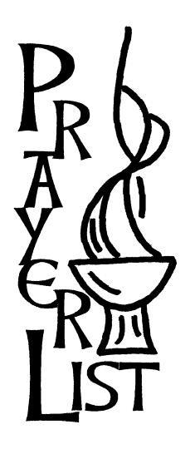Megan Thurston, Grace Buczny, Judy Adams, Matthias Ronning, Art and Eleanor Tross, David Price, Bob Gleason, Denise Kladis, Jon Antal, Val Evans, Jeanette Scott, Andrew Porche, Sara Colanthia Carignan, Angelo Collins, Jr., Liam Scott, Judy Calistri, Bonnie Wilhelm, Theresa Brady, Al Orlick, Kristin Huggins, Dorothea Rose and Elizabeth Grace Hubbard, Diane Cioffi, Sarah Stansberry, Marjorie Briden, Roberta Romeo, Jennifer Eder, Hunt Addison, Sharon Sanderson, Patricia Keane, Gerri Guyon, Joe Witek, Rosemarie Della Penna, Louise Weber, Roger Smith, Guy Doughty, Rip Phillips, Mike Strub, Bev Stetar, Chris Bannon, Billy Powell, Lloyd Kellam, Sherry Lawson, Michael Gazzolo, Joe Paschall, Steve Welde, Wilhelmina Holman, Betty Webb, Eve Mlodynia

**Whenever a parishioner is sick or in the hospital, please call the rectory or send e-mail to:** [**bulletinscc@gmail.com**](mailto:bulletinscc@gmail.com) **for inclusion in our bulletin.**

**If a person is no longer in need of our ongoing prayers, please let us know.**

**Join our Parish Family**

We cordially invite you, to become a registered member of our Parish. There are several benefits to being a registered member such as: obtaining letters of recommendation, permission letters to baptize in other parishes, immigration letters and more.

Your weekly donations are recorded and tax deduction letter provided at your request at the end of the year. Your information is confidential.

Please stop by the parish office today and complete a membership application.

**FINANCIAL REPORT**

The annual report on the financial health of our church for fiscal year 2021-2022 is available in the rear of the church.

**Pray for Peace and Protection**

**of Members of Our Uniformed Services**

**Lord**, bless the men and women of our military as they answer the call to serve our nation and defend our freedom. Protect them, particularly those in harm’s way. Most of all let them know your love: that you are with them, and that you will never forsake or abandon them. We ask this in the precious name of Jesus, our Lord and Savior. ***Amen***.

**PVT Patrick P. Podlaski** – Nephew of John Woolaver.

**Master Sergeant E7 Samuel David Fallon** – Son of Kevin and Karey Fallon.

**1st Lieutenant PA Jason Hill** – Son of Grover and Pat Hill.

**Staff Sergeant Maribel Surran** – now serving at Fort Carson, Colorado. Daughter-in-law of Dick and Marge Surran.

**PFC Marisol Surran** – deployed to Germany. Granddaughter of Dick and Marge Surran.

**1st Lieutenant Samuel Davis McQuitty** – Grandson-in-law of Peggy and Rip Phillips. Stationed at Fort Hood, Texas.

**Lieutenant Colonel Tracy Martin** – Son-in-law of Bob and Sue Panek.

**1st Lieutenant Katherine Lee** – Daughter of Patricia and Robert James.

**Staff Sergeant Dustin Goard, SERE Specialist** – Son-in-law of Mike and Deirdre Purcell.

**1st Lieutenant Kevin Rech** – Son of Kevin and Judy Rech.

**Captain Clay Lewin** – Son of Kurt and Sally Lewin and Grandson of Maureen and Don Donovan.

**Captain Sean Mitcham** – Son of Denise Mitcham.

Please let us know the name of your loved one serving in the Armed Forces. E-mail to: bulletinscc@gmail.com

**Collection for September 17 & 18: = $ 2,555.00**

**Total Offertory for September: = $ 8,632.00**

**2nd Collection for “Retired Religious”: = $1,386.00**

**September Preservation Fund: = $ 2,048.00**

Saint Charles Church depends on your weekly support for operating expenses. Average weekly collection needed for 2022-23 budget is $3,925.00.

All checks (unless otherwise noted) should be

made out to **“**Saint Charles Church”.

Thank you for your cooperation.

**Mass attendance September 17 & 18:**

**Saturday 67 = Sunday = 96 & 57**

**In Memory of**

**Fred Meditz**

**Given by Eve Mlodynia**

**Arranger: Michael Flanagan**

**Arranger Next Week: Diane Partin**

**My Gift to You Candles**

**Sanctuary Light Month of September**

**In Memory of:**

**Ante M. Pinili**

**Given by Evelyn, Froi, Matt & Charly**

**Father Robert Barron’s**

**UNTOLD BLESSING**

***Three Paths to Holiness***

God calls each of us to become a saint, and he’s ready to support us along the way by providing abundant blessings.

Join us as we seek these blessings by participating in Bishop Robert Barron’s DVD-based program:

**“Untold Blessing: Three Paths to Holiness”**

The first path is: “Finding the Center in Christ;”

the second is: “Knowing You Are a Sinner;”

and the third: “Realizing Your Life is Not About You.”

**On Saturday, October 8th, following the 5:00 p.m**. Mass, our parish will begin the “Untold Blessing: Three Paths to Holiness” program. There will be 6 classes, on alternating Saturdays. For more information, please contact Karen Leffel [stcharlesstudy@gmail.com](mailto:stcharlesstudy@gmail.com). I am looking forward to having you there!

**MIGRANT MINISTRY NEWS/UPDATE**

For our workers at the camps we are accepting donations of gently used or new TWIN size blankets as this need has been expressed by the workers. Please contact Karey & Keven Fallon should you have any questions at (757) 784-1965. Thank you for your continued support of our workers.

**Information**

**“Baked Goods” Table/Octoberfest**

**In conjunction with the Octoberfest, there will be a table with “goodies” for purchase. Please drop off your “goodies” (clearly marked/priced/allergy info) at the Parish Hall beginning Friday, September 30 from 10:30 a.m. to 1:30 p.m. or Saturday, October 1 from 9:00 a.m. to 1:00 p.m. Please use the Tazewell Avenue entrance to the Parish Hall. If you have any questions and/or if you will provide a “goody or two”, please contact Mary Beth Briggs at 678-5036.**



**ROSARY FOR THE MONTH OF OCTOBER**

**Every weekend during the month of October, we will pray the Rosary before Mass.**

**Blessing of the Pets**

**On Saturday, October 8th Father Michael Breslin will have a “Blessing of the Pet” at 11:00 a.m. The “festivities” will take place outside the Church.**

**The following items are greatly needed. Please consider donating any of the items at the Blessing and they will be given to the Eastern Shore SPCA:**

* **Pure Balance Small Breed dog food**
* **Purina One dog food**
* **Nudges Steak Grillers Dog Treats**
* **Purina Cat Chow Indoor (green bag)**
* **Purina Kitten Chow**
* **Temptations cat treats**
* **Friskies can cat food (not “paté”)**
* **Non-clumping clay cat litter**
* **Dawn dish liquid**
* **Liquid laundry detergent**
* **Bleach, Dryer sheets, Paper towels**
* **Donations & gift cards in any amount**

**October’s “DONUT SUNDAY” will be October 9th. Please join us in the Parish Hall after the 10:00 a.m. Mass. All parishioners and visitors are invited to attend.**

**Información**

**Mesa “Productos horneados”/Octoberfest**

En conjunción con el Oktoberfest, habrá una mesa con "golosinas" para comprar. Deje sus "obsequios" (claramente marcados/precio/información sobre alergias) en el Salón Parroquial a partir del viernes 30 de septiembre de 10:30 a. m. a 1:30 p. m. o el sábado 1 de octubre de 9:00 a 13:00 horas. Utilice la entrada de Tazewell Avenue al Salón Parroquial. Si tiene alguna pregunta y/o si va a proporcionar un "obsequio o dos", comuníquese con Mary Beth Briggs al 678-5036.



**ROSARIO POR EL MES DE OCTUBRE**

**Todos los fines de semana del mes de octubre rezaremos el Rosario antes de la Misa.**

**Bendición de las mascotas**

El sábado 8 de octubre el Padre Michael Breslin tendrá una “Bendición de la Mascota” a las 11:00 a.m. Las “festividades” se llevarán a cabo fuera de la Iglesia.

Los siguientes elementos son muy necesarios. Considere donar cualquiera de los artículos en la Bendición y se entregarán a Eastern Shore SPCA:

• Alimento para perros de razas pequeñas Pure Balance

• Comida para perros Purina One

• Premios para perros Nudges Steak Grillers

• Purina Cat Chow Indoor (bolsa verde)

• Comida para gatitos Purina

• Tentaciones golosinas para gatos

• Comida para gatos en lata Friskies (no “paté”)

• Arena para gatos de arcilla no aglomerante

• Líquido para platos Dawn

• Detergente líquido para ropa

• Blanqueador, sábanas para secadora, toallas de papel

• Donaciones y tarjetas de regalo de cualquier monto

**El “DOMINGO DE DONUT” de octubre será el 9 de octubre. Únase a nosotros en el Salón Parroquial después de la Misa de las 10:00 a.m. Todos los feligreses y visitantes están invitados a asistir.**

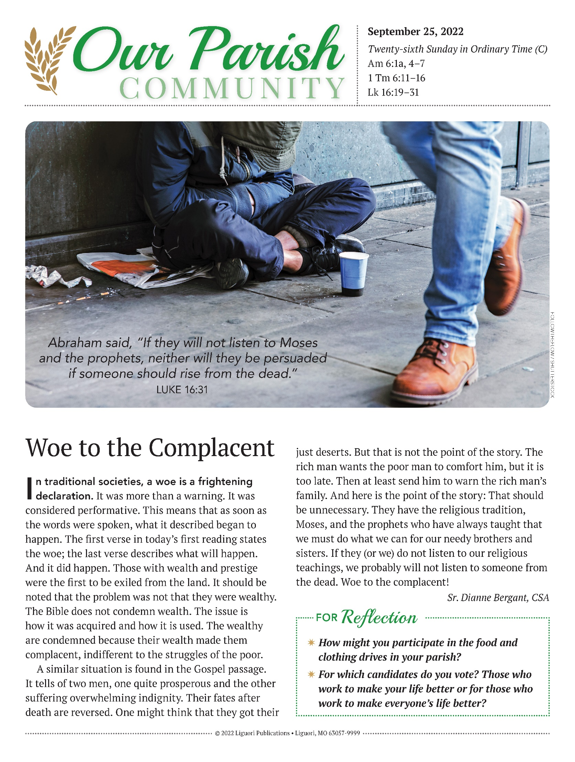

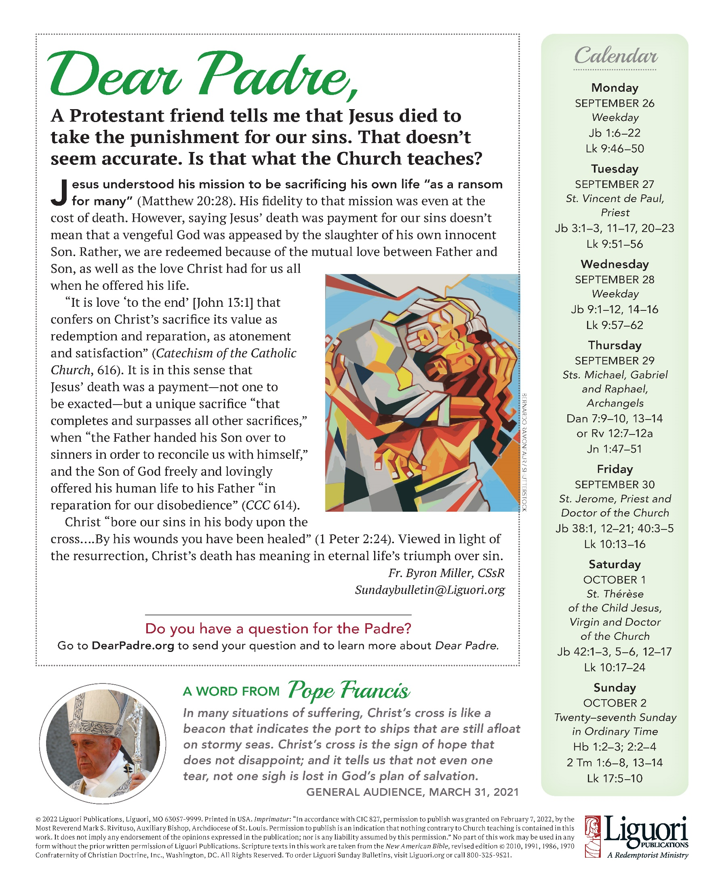

|  |  |
| --- | --- |
| **OCTOBER 2022** | **Birthdays and Anniversaries** |

|  |  |  |  |  |  |  |
| --- | --- | --- | --- | --- | --- | --- |
| **Sunday** | **Monday** | **Tuesday** | **Wednesday** | **Thursday** | **Friday** | **Saturday** |
|  |  |  |  |  |  | 1 |
|  |  |  |  |  |  | **Anniversary:**  Spencer & Rachel Travis  **Birthday:**  Spencer Travis |
| **2** | **3** | **4** | **5** | **6** | **7** | **8** |
|  |  | **Birthday:**  Francisco Rodriguez  Stanley Osmolenski | **Birthday:**  Amy Watkins  Giselle Cruz | **Birthday:**  Thomas Fox | **Birthday:**  Philip Evans  Ethan Watkins |  |
| **9** | **10** | **11** | **12** | **13** | **14** | **15** |
|  | **Birthday:**  Patricia Hill |  | **Anniversary:**  Joe & Scottie Paschall  **Birthday:**  Donaciano Cruz | **Anniversary:**  Rip & Peggy Phillips | **Birthday:**  Palmer Travis | **Anniversary:**  Thom & Irene Henderson |
| **16** | **17** | **18** | **19** | **20** | **21** | **22** |
| **Anniversary:**  Jeff & Laurie Klingel  **Birthday:**  Maiela Hossain Clarke  Felipe Rodriguez | **Anniversary:**  Joe & Evelyn Witek  **Birthday:**  Robert Crowley |  |  | **Birthday:**  Eve Mlodynia | **Birthday:**  Ricardo Morales | **Birthday:**  Editha Lockwood |
| **23** | **24** | **25** | **26** | **27** | **28** | **29** |
|  | **Anniversary:**  Joe & Marta Rose  **Birthday:**  Melisa Jaramillo | **Anniversary:**  Manny & Diane Said  **Birthday:**  James Clark  Kevin Rech | **Birthday:**  Marjorie Briden  Herb Thom  Patricia Milton | **Birthday:**  Michael Kurgan | **Birthday:**  Jose Palacio | **Birthday:**  Dorothy Riley |
| **30** | **31** |  |  |  |  |  |
| **Birthday:**  Irene Henderson | **Birthday:**  Susan Kovacs |  |  |  |  |  |

For those who are interested, please complete the form below and place in the collection basket at Mass or you may drop it off at the Parish Office. Thank you.

**An Invitation to Serve**

**Greeter, Usher, Choir Member, Lector, Eucharistic Minister,**

**Adult/Youth Altar Server, Altar Flower Arranger, Polisher,**

**Fund Raising, Helping Hands, Parish Life, Religious Education, Worship**

Please consider serving at our Parish. All parishioners are invited to apply for any of these Ministries at

Saint Charles Church. Training will be provided for adults and children (who have received their First Eucharist). If you are interested in being part of any of these Ministries complete the application below and return it to the Parish Office or call the Parish Office at 331-2040.

Parents can be assured that children participating in the Altar Server Ministry of our Parish are safe and well protected by the policies that have been established by the Diocese of Richmond.

Thank you for your thoughtful and prayerful consideration,

J. Michael Breslin, Pastor

Name: _______________________________________________________________________

Address: _____________________________________________________________________

Phone Number: _________________ Email Address: __________________________________

**Please CHECK which Mass time(s) you would prefer to serve:**

* **Saturday @ 5:00 p.m.**
* **Sunday 9:00 a.m. (English Memorial Weekend to Labor Day Weekend)**
* **Sunday 10:00 a.m. (English)**
* **Sunday @ 4:00 p.m. (Spanish)**
* **or I will serve where I am needed**

I will attend practice and training sessions when scheduled. I will faithfully serve on weekend and holy days of obligation and I will do my best to follow through with my commitment or get a substitute if I am unable to attend my scheduled service.

Signature: _________________________________________ Date: ______________________

**If applicable:** I approve of my child's desire to be an Altar Server at Saint Charles Church and I will support him/her in getting to Church and in keeping to the schedule. Also, please provide the following information:

Child’s Grade: _________ Child’s Age: ________

Parent(s) Name(s): _____________________________________________________________

Parent's Signature: __________________________________ Date: ______________________